# Final Black Logo BgPixel HullOS Editor

Version 1.0

Rob Miles

HullOS is an operating system designed for use in small robots and the Hull Pixelbot. It provides an extensible scripting language that can be used to create programs that are stored inside an Arduino based device. The programs can be downloaded into the device using the serial port and are stored inside the Arduino using its internal EEPROM. When the Arduino is powered on the HullOS program stored in it is automatically executed. You can find out about the HullOS system by reading the documentation, which is here:

https://github.com/HullPixelbot/HullOS/blob/master/HullOS%20Specification.pdf

This document describes the HullOS Editor. This is a Python program that you can us to create and edit HullOS programs. You can run it on any system that supports Python 3.6 and can run the pyserial library.

# Installation

Install the program by copying it into your target folder. Ensure you have installed the pyserial library before running it, or it won't end well.

# Start the editor

Run the editor as you would any other Python program on your system:

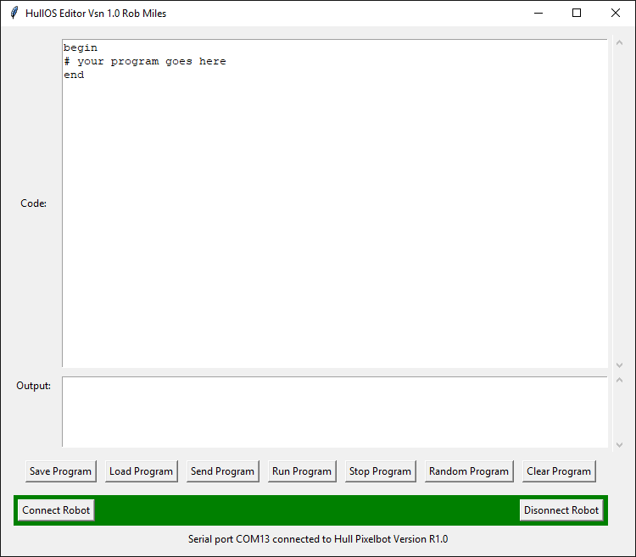

There are two large text areas in the editor. The Code area is where you type your programs. The Output area is where messages from the robot are displayed. The bottom line of the editor shows status messages.

# Connect to a robot

You can connect a robot to any serial connection on your computer. The robot should be running HullOS. The editor will automatically search for connected robots. If you have multiple robots connected to your computer it will connect to the first robot that it finds.

The connection takes place when the program starts. You can use the Connect Robot and Disconnect Robot buttons to manage the robot connection. If you unplug your robot while using the program it will automatically be re-connected when you plug it back in again. The connection status is shown along the bottom of the editor window. If the bar is red the robot is not connected.

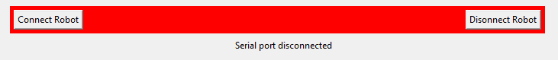

When it turns green you can send programs into the robot. You should only need to disconnect the robot if you want other programs to use the serial connection.

# Write a program

You can enter your program code into the code window in the editor. Remember to start the program with the keyword begin, and end the program with end. Refer to the language documentation (above) for details of the language.

# Save or Load a program

You can use the Save Program and Load Program buttons to save and load program files. These are just text files.

# Send a program to the robot

To send a program the robot press the Send Program button. The program currently in the robot is erased and the new one downloaded. You should see the pixel on the robot display a rotating dot as the program is downloaded. Once the program has been downloaded it will be executed. If there are any errors in the program, these will be displayed in the Output window.

# Run a program

Use the Run Program button to run a program that has finished. **Note that this button doesn't download the program into the robot, it just runs the program that is already there.**

# Stop a program

Use the Stop Program button to stop a program running.

# Get a random program

There are a few sample programs held inside the editor. Press the Random Program button to get one of these to play with. See if you can work out what the program does, and make some improvements of your own.

# Clear the editor

You can clear the currently edited program and start editing a new, empty one, by pressing this button.